AN EXAMPLE
SBAR Communication using Teamwork and Collaboration
By NAME RN-BS Student
Quality and Safety Education for Nurses (QSEN) is aimed at educating nurses at improving the safety and quality of care within the healthcare system (QSEN, 2020). Teamwork and collaboration are one of the six competencies and is defined as “function effectively within nursing and inter-professional teams, fostering open communication, mutual respect, and shared decision-making to achieve quality patient care” (QSEN, 2020). Nurses, whether novice or expert, must follow proper communication methods that reduce the risk of errors that can potentially lead to inadequate patient care. Poor communication increases the risk of sentinel events in the healthcare setting; therefore, effective communication is crucial for the delivery of safe patient care (Stevens, McNiesh, Goyal, 2020).
Research supports the use of the Situation-Background-Assessment-Recommendation (SBAR) communication tool. This is a standardized and systemic way of communicating with team members that provides a framework for effective, understandable, and safe communication among all healthcare professionals involved in a patient’s delivery of care (Stevens, McNiesh, Goyal, 2020). Patients signs and symptoms can change significantly, and as nurses we must recognize these changes and be able to relay the information to the other healthcare members on the team in a timely and effective manner. The SBAR components are easy to remember and are structurally useful in communicating, especially in critical situations when the need for the physician’s actions and orders are needed (Institute for Healthcare Improvement, 2021).
- Situation: a concise statement of the problem
- Background: brief but pertinent information related to the situation
- Assessment: evaluation and considerations (what you found or think)
- Recommendation: action requested or recommended (what you want)
Based on nurse theorist Patricia Benner’s learning model, nurses move through five levels of skills: novice to expert. Benner believes that nurses start out as a beginner or novice and learn and acquire skills by repetition and ongoing clinical experiences, then build upon higher levels of skills and delivery of nursing care (Stevens, McNiesh, Goyal, 2020). With the lack of experience a novice nurse can have in communication of vital health information, it is crucial for nursing students to become familiar in the use of standardized communication tools. The incorporation of these standardized communication frameworks like SBAR in nursing education programs can allow nursing students to practice, role play, and become proficient with proper and safe communication of appropriate patient information and develop the skills needed for the delivery of safe patient care (Stevens, McNiesh, Goyal, 2020).
Patient safety and quality of care is essential and implementing a universal communication framework like SBAR is a useful and effective way to create a consistent and organized approach, whether a nurse is a student, novice, or expert.

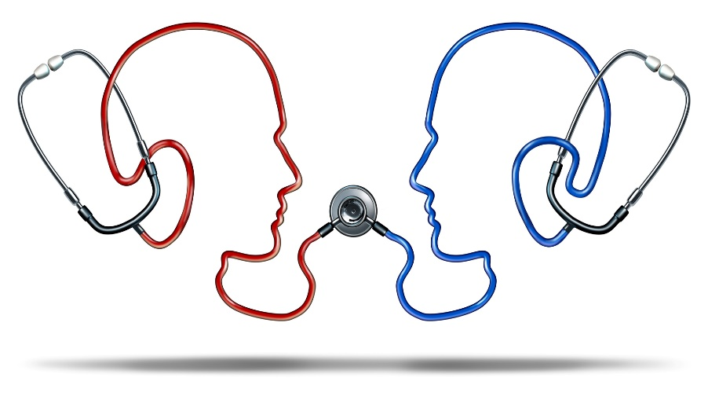

References
Institute for Healthcare Improvement. (2021). SBAR Tool: Situation-Background-Assessment-Recommendation. http://www.ihi.org/resources/Pages/Tools/SBARToolkit.aspx
Stevens, N., McNiesh, S., Goyal, D. (2020). Utilizing an sbar workshop with baccalaureate nursing students to improve communication skills. Nursing Education Perspectives, 41(2), 117-118.
Quality and Safety Education for Nurses (2020). QSEN competencies. Retrieved from https://qsen.org/competencies/pre-licensure-ksas/

